

Analysing Chifley Suburb Property Prices

Submitted By- Kushal Ahuja (14191922)

Table of Contents
Data Preparation 3
Visualisation 4
Supply and Demand 4
Property Price 5
Finance 6
Population 7
Ownership 8
Workforce 9
Dwelling 10
Family 11
Visual Analytics 12

Data Preparation
This dataset is collected from the Australian Bureau of Statistics (ABS) website for Chifley, a New South Wales State suburb. It consists of the information of the following attributes –
- Property Price
- Finance details (Income & Mortgage)
- Population
- Ownership
- Workforce (Employment)
- Dwelling Status
- Families

This data is being collected from census data for the years 2001, 2006,2011,2016 and 2021.

This dataset contains numerical data of categorical attributes/ variables. The 7 different attributes through which the dataset can be analysed are-
- Property Price- It illustrate the median house and unit price.
- Finance details- It shows the personal, family and household income and also their mortgage and rent payment information.
- Population- It includes people, their median age and their marital status.
- Ownership- It states the owning of house such as separate house, Semi-Detached house and Apartment.
- Workforce- It demonstrates the data related to employment of individuals and also their type of work i.e. part-time or full-time.
- Dwelling- Data related to type of house and units are included.
- Family- Details such as couples with and without children or one parent family.
Data style is majority of percentage values while at some place it is numbers and currency.

The pattern is both upwards and decline, ex. there is surge in population while decline in fully owned houses.

To analyse the 7 attributes better the data has been rearranged as a part of the task of data preparation resulting in creating and analysing the required output.
Examples of rearranging data are –
- Change in prices, income, mortgage, family details and dwelling status is being created to analyse the change in an efficient way comparing with the previous years.
- New rows added named Demand and Supply vs Demand to analyse the property prices as per the average number of people per household and also to visualise and analyse the relation of supply and demand.

Visualisation

Supply and Demand

The relation between supply and demand is visualised by the given data. Moreover, Demand in the given table is being calculated by dividing the population with average number of people per household. The total private dwelling is the supply of property available in the given year at Chifley.
(The data of year 2001 is not added due to the non-availability of average number of people per household in ABS). As the table states that there has been surge in population resulting in the increase of demand over the years except in the year 2006. To cope up with the demand the supply is also increased i.e., more availability of property to buy. The change in each category i.e., demand, supply and population is calculated by dividing the data with the previous year’s data. To analyse the change and relation between the variables the comb chart is created.

Visualisation technique
The combo chart is used to create the visualisation for understanding the supply, demand and population change with respect of the certain years. This chart is ideal to use due to the option of adding secondary axis resulting in adding several attributes/ variables in one chart. While depicting various data that are assessed using various scales, a combination chart is the right way to visualise it.
This combo chart is with the stacked columns (for Population, Supply and Demand) and stacked lines with marker (for the change in the given variable over the years).
Data labels is being added and repositioned for better understanding. Arrow is added with the analysed information.

Summary
As per the combo chart and the data it is evident that population witnessed a similar change compared to demand and supply. Over the years between 2006 and 2016, there was less change in comparison to that of year 2021. All the three variables got an increase in 2021 with a significant change as the change in population and demand is of 5% while supply got a 4% change resulting in more demand.
Other years witnessed 1% to 3% change in all the given variables.

Property Price

Summary

As per the combo chart it is evident that there has been a drastic change in the house and unit prices in twenty years. The unit price has witnessed more significant change compared to the house price. The unit price has surged with 397% from 2001 to 2021 with having a change of about on average of 30% in every 5 years. In the year of 2011 the unit price has increased to 133% resulting in the biggest leap.
House prices also witnessed a significant upward trend having a change of 400% in the span of twenty years. In 2011 the unit price change shows that there has been an increasing demand for apartments in contrast of the houses, while in 2016 the change for house price shows that the demand for house was more than that of apartment or units.
Nevertheless, both unit and houses had given a great return as an asset to people investing or buying them in Chifley.

Visualisation Technique
The combo chart is used to create the visualisation for house price and unit price and the change in the prices. This chart is ideal to use due to the option of adding secondary axis resulting in adding several attributes/ variables in one chart like house price change and unit price change plotted on the basis of secondary axis. This combo chart is with the clustered columns (for Median house and Unit Price) and stacked lines with marker (for the change in the given variable over the years).
Data labels is being added and repositioned for better understanding. Arrow is added with the analysed information.

Finance
Visualisation Technique

The combo chart is used to create the visualisation for plotting income, mortgage and rent. This chart is ideal to use due to the option of adding secondary axis resulting in adding several attributes/ variables in one chart like annual household income plotted on the basis of secondary axis. This combo chart is with the clustered columns (for household mortgage and rent payment) and stacked lines with marker (for the change in the annual household income over the years).
Data labels is being added and repositioned for better understanding. Arrow is added with the analysed information.

Summary

The visualisation for finance includes Income, Mortgage and Rent Payment data, by analysing income in contrast to the mortgage and rent, it is easier to know the financial condition of people residing in Chifley,
It is evident from the below graph that Annual Household Income has increased dramatically with a change of 112% and thus resulting in reduction of Mortgage payment and rent payment over the years. But in year 2021 the rent payment has been increased to 17.31% from 13.05% resulting in the less change when compared to twenty years.
The annual household income increased at a steady rate from 2011 to 2021.

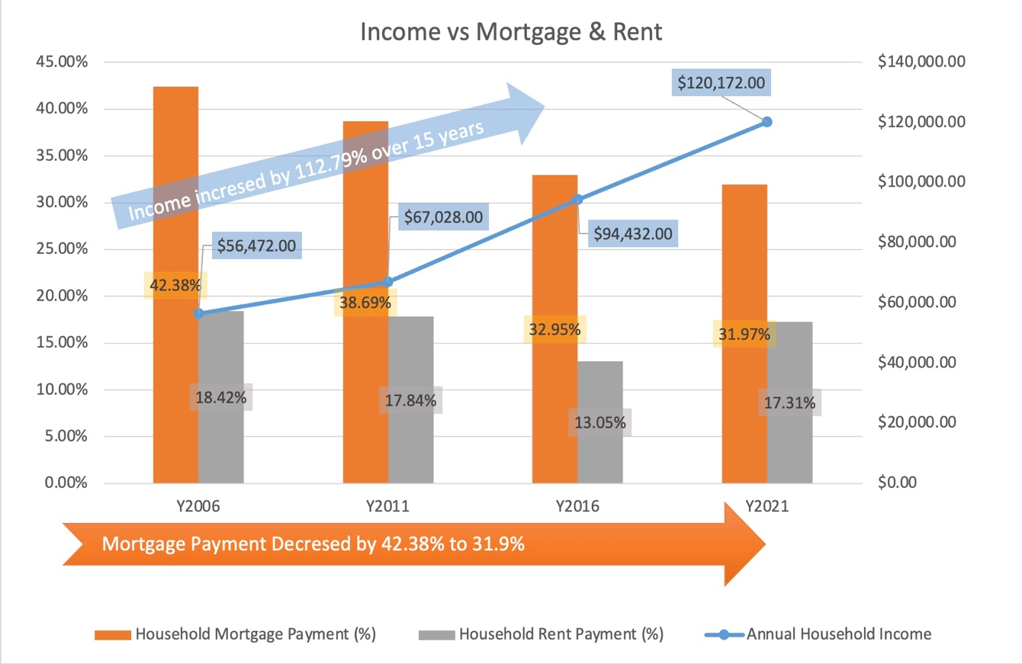

Population

Visualisation Technique

The combo chart is used to create the visualisation for plotting population and marital status. This chart is ideal to use due to the option of adding secondary axis resulting in adding several attributes/ variables in one chart like Marital Status plotted on the basis of secondary axis. This combo chart is with the clustered column (for population) and stacked lines with marker (for the change in the marital status of population over the years).
Data labels is being added, coloured, and repositioned for better understanding. Arrow is added with the analysed information.

Summary

It is evident from the graphs that the majority of the population is married with about 50% in the recent years, the person who are never married are also a significant part of the population as they have been increased from 30.6% to 35.4%. The widowed and separated + divorced person are certainly less and also been reduced since 2006 as it has shown a downward trend.
The second graph demonstrates the change in the marital status with their values in certain years.

Ownership

Visualisation Technique

The combo chart is used to create the visualisation for plotting Ownership and population. This chart is ideal to use due to the option of adding secondary axis resulting in adding several attributes/ variables in one chart like Family, Single Person and Group Households plotted on the basis of secondary axis. This combo chart is with the clustered columns (for Fully Owned, Owned with Mortgage and Rented) and stacked lines with marker (for the change in the Family, Single Person and Group Households over the years).
Data labels is being added, coloured and repositioned for better understanding. Arrow and trendlines are added with the analysed information.

Summary

It is evident from the graph that fully owned houses by individuals, group and family are decreasing, while in contrast the houses owned with mortgage and rented houses are increasing as people may not be able to afford the high prices of houses in the last 5 to 10 years.
Population can also be the reason for this as the second graph shows that population has been increasing steadily from 2001 to 2016 and dramatically till 2021. People living as single and group household had reduced from 2001 to 2006 but then increased in 2011 and has been steady till 2016 and got slightly reduced in 2021.
In recent years the rented houses are reduced from 31.7% to 30.3% while the owned with mortgages are increased from 32% to 33.8%.

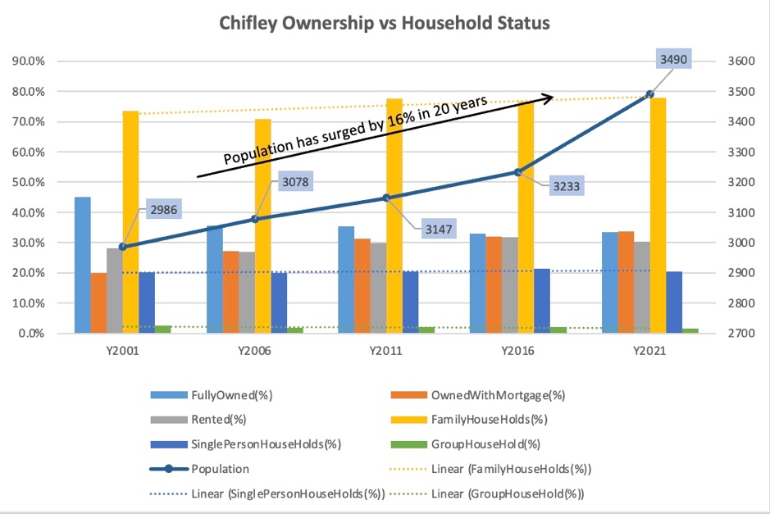

Workforce
Visualisation Technique

The clustered bar chart is ideal to visualise the workforce data as it is more convenient and easier to understand.
The Data Labels has been added and the trendline for getting to know the scalability of a single column or variable over the years.
Legend is added to know the year for the data of variables.

The second visualisation is Line graph to know the changes of particular variables.

Summary

It is evident from the graphs that Worked full-time has increased from in year 2001 from 62.5% to 64.4% in 2006 and then declined till 2016 while, part-time workers have reduced in year 2001 from 30.1% to 25.7% in 2006 but then it increased to 31.2% in 2016. This explains that some individuals are liking to work part-time than full-time. The unemployment rate remains constant throughout the twenty years at 4.1%.

Dwelling

Visualisation Technique

The combo chart is used to create the visualisation for plotting population and marital status. This chart is ideal to use due to the option of adding secondary axis resulting in adding several attributes/ variables in one chart like Separate, Semi-Detached and Flat Unit apartment plotted on the basis of secondary axis. This combo chart is with the clustered column (for occupied and unoccupied dwellings) and stacked lines with marker (for the change in the Separate, Semi-Detached and Flat Unit apartment over the years).
Data labels is being added, coloured and repositioned for better understanding.

Summary
The Occupied dwelling got reduced from year 2011 at 94.7% to 91.9% in 2016 and then increased by 1% till 2021, while Unoccupied dwelling increased from 5.3% in year 2011 to 8.1% in 2016 and then reduced 6.9% till 2021. The only dwelling which increased over ten years is Separate house dwelling from 20.1% to 25.4% while apartment and separate house dwelling increased and decreased respectively. And then changed to the inverse direction i.e., downward and upward movement respectively.
The second graph shows the change in these dwellings.

Family

Visualisation Technique
The combo chart is used to create the visualisation for plotting population and marital status. This chart is ideal to use due to the option of adding secondary axis resulting in adding several attributes/ variables in one chart like Couple Family with Children and no children, One parent family and other family plotted on the basis of secondary axis. This combo chart is with the clustered column (for families) and stacked area with marker (for Couple Family with children and no children, one parent family and other family).
Data labels is being added, coloured and repositioned for better understanding. Trendline is added in second chart to compare the change over the years.

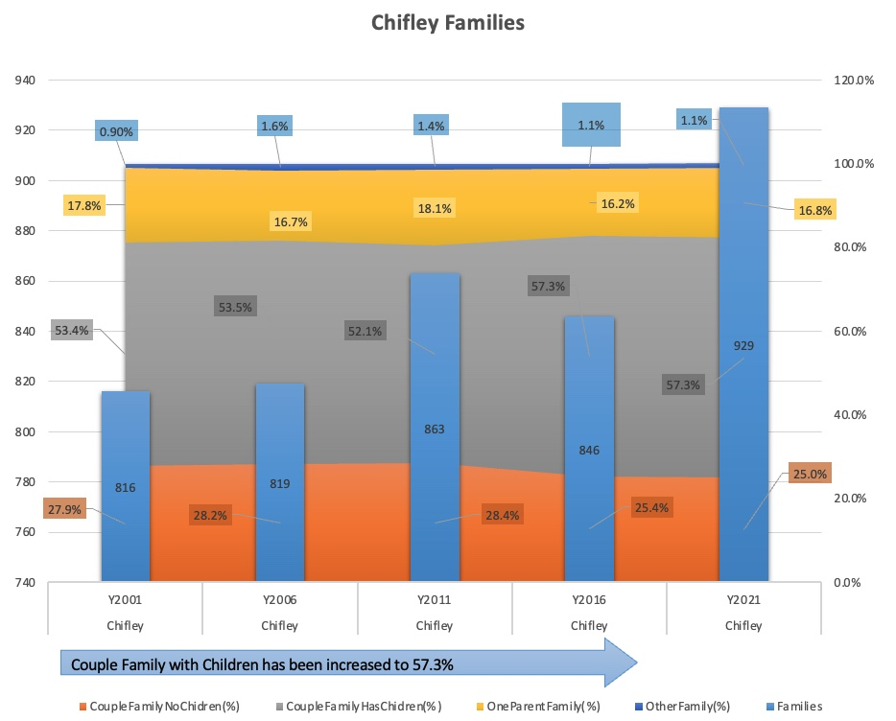

Summary

It is evident from the graphs that majority of the families are having children, the second most common families are having no children followed by one parent family with 16.2% in recent years the least is other families with 1.1% in recent years.
The second graphs shows the change in this variables, it is visible that other family change is more volatile than the one parent family and couple family with no children.
The number of families increased drastically in 2021 from 846 to 929 families.

Visual Analytics

The Chifley dataset came from the Australian Bureau of Statistics (ABS) website in the census data for the years 2001, 2006, 2011, 2016 and 2021. The dataset includes details regarding population, property prices, families, dwellings, employment, ownership and finance (income, mortgage and rent payment) for the particular suburb, i.e., Chifley.

To analyse the 7 attributes better the data has been rearranged as a part of the task of data preparation resulting in creating and analysing the required output.
Examples of rearranging data are –

- Change in prices, income, mortgage, family details and dwelling status is being created to analyse the change in an efficient way comparing with the previous years.
- New rows added named Demand and Supply vs Demand to analyse the property prices as per the average number of people per household and also to visualise and analyse the relation of supply and demand.
- Demand to Supply ratio is also calculated for convenience and better visualisation.
- Annual Household Income is calculated for comparison with the mortgages and rent payments.

Due to the multi-dimensional data I have created combo charts as it is the only way to deal with that to create the visualisation in one chart or a graph. I have used various visualisation techniques to create the graphs and make it easier to understand the insights of Chifley,
- Data Labels – I have added data labels in each graph for convenience as it makes the visualisation easy to understand and more meaningful. I have also coloured them to know which variable states that label. Additionally, repositioned it so to avoid the over lapping of data.

- Trendlines- Added trendlines to compare the variable change with the past years, and also to know the relationship between variables or attributes.

- Shapes and arrows- Added shapes and arrows to demonstrate the upward and downward trend, specially which shows the significant change.

This techniques helped the visualisation storytelling to be more expressive.

The trend which showed a change in unit and house price are significant because it shows the livelihood of Chifley , it got a huge increase over the decade depicting that buyer or an investor should buy the house or unit in Chifley as it would provide them a good return on investment based on the findings through the visualisation of past two decades.
The advantages of visualisation techniques that I used are it makes the stake holder more engaged and user friendly, additionally it makes the complex relationship easier to understand and also to identify the patterns in an efficient and more meaningful manner.

